Name: Praxedes Jr., George Q. BSIT305

This is the Water character of the game we are creating. The progression of the game looks like a clone of super Mario brothers game that was made in September 13, 1985. The game is an imagining side investigating characterization where you have to finish the game by saving the princess. The game is commonly like a clone anyway you ought to just to accomplish the game with enemies without letting your lives cleaned. The image has 3 lives and 3 powerups. The maxim of the game is "Do your best util the end never give up."

Character:

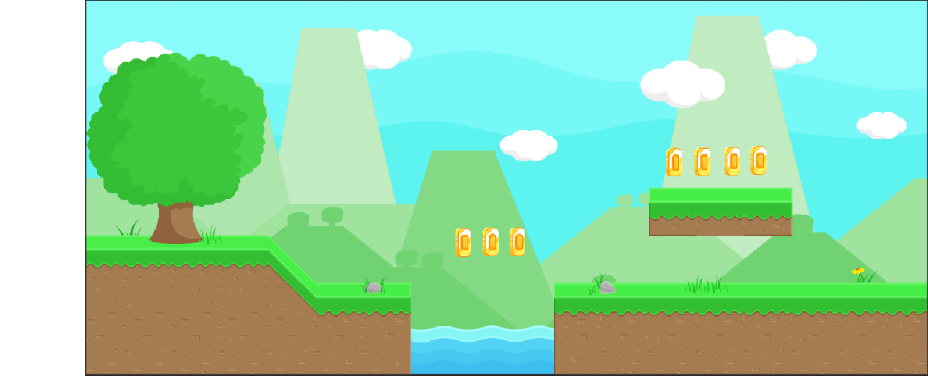Backgroud: